**Project Design Phase-II**

**Solution Requirements (Functional & Non-functional)**

|  |  |
| --- | --- |
| Date | 03 November 2023 |
| Team ID | NM2023TMID02207 |
| Project Name | Project – HASHTAG GENERATION |

**Functional Requirements:**

Following are the functional requirements of the proposed solution.

|  |  |  |
| --- | --- | --- |
| **FR No.** | **Functional Requirement (Epic)** | **Sub Requirement (Story / Sub-Task)** |
| FR-1 | Hashtag Generation | FR-001.1: Keyword Analysis for Hashtags  FR-001.2: Real-time Hashtag Suggestions  FR-001.3: Customization of Suggested Hashtags |
| FR-2 | Scalability | FR-002.1: Cloud-Based Scalability  FR-002.2: Load Balancing for Performance |
| FR-3 | Cross-Platform Compatibility | FR-003.1: Responsive Web Design  FR-003.2: Mobile App Compatibility |
| FR-4 | Trending Hashtags | FR-004.1: Fetching and Displaying Trending Hashtags |
| FR-5 | Multilingual Support | FR-005.1: Multilingual Hashtag Generation |
| FR-6 | User Interface (UI) | FR-006.1: User-Friendly Hashtag Input  FR-006.2: Hashtag Selection Interface |

**Non-functional Requirements:**

Following are the non-functional requirements of the proposed solution.

|  |  |  |
| --- | --- | --- |
| **FR No.** | **Non-Functional Requirement** | **Description** |
| NFR-1 | **Usability** | The application should have a user-friendly interface, making it easy for users to input content and select hashtags. |
| NFR-2 | **Security** | Ensure that user data is secure, and the application complies with data protection regulations. |
| NFR-3 | **Reliability** | The application should be reliable, with minimal downtime and errors, ensuring users can generate hashtags without interruption. |
| NFR-4 | **Performance** | The application should perform efficiently, generating hashtags quickly to keep up with the user's workflow. |
| NFR-5 | **Availability** | The application should be available to users at all times, ensuring they can access hashtag generation features when needed. |
| NFR-6 | **Scalability** | The application should be designed to scale easily, especially for high-demand periods or as the user base grows. |

**Project Design Phase-II**

**Data Flow Diagram & User Stories**

|  |  |
| --- | --- |
| Date | 03 November 2023 |
| Team ID | NM2023TMID02207 |
| Project Name | Project – HASHTAG GENERATION |

**Data Flow Diagrams:**

A Data Flow Diagram (DFD) is a traditional visual representation of the information flows within a system. A neat and clear DFD can depict the right amount of the system requirement graphically. It shows how data enters and leaves the system, what changes the information, and where data is stored.



**Example: (SV ORGANICS)**

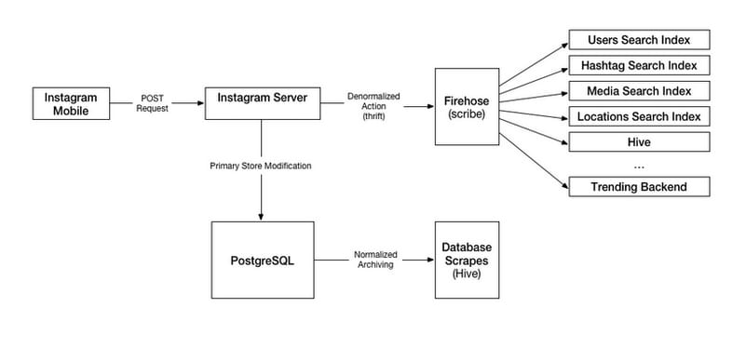

**User Stories**

Use the below template to list all the user stories for the product.

| **User Type** | **Functional Requirement (Epic)** | **User Story Number** | **User Story / Task** | **Acceptance criteria** | **Priority** | **Team Member** |
| --- | --- | --- | --- | --- | --- | --- |
| Marketing | Social Media Enhancement | USN-1 | generate hashtags for posts | generate relevant hashtags based on content. Include at least 10 hashtags per post. | High | Deepika.k |
| Content team | Content optimisation | USN-2 | Research and suggest hashtags | Research and provide a list of relevant | medium | Jaipriya.S |
| Analytics | Analytics integration | USN-3 | Track hashtags performance | Ensure that hashtag usage and engagement metrices are trackled and analysed | high | Nithyarupini.G |
| Blogger | e-Commerce | USN-4 | Suggest long-tail and niche hashtag | Niche hashtag to target specific audience that are interested | High | Swetha.S |

**Project Design Phase-II**

**Technology Stack (Architecture & Stack)**

|  |  |
| --- | --- |
| Date | 03 - Nov 2023 |
| Team ID | NM2023TMID02207 |
| Project Name | Project – HASHTAG GENERATION |

**TECHNICAL ARCHITECTURE**

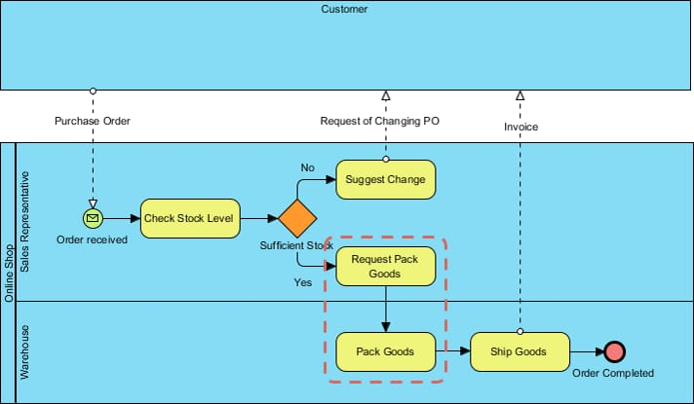

**Table-1 : Components & Technologies:**

|  |  |  |  |
| --- | --- | --- | --- |
| **S.No** | **Component** | **Description** | **Technology** |
|  | Hashtag Generation Engine | Engine For Generating Tags | NLP and AI algorithms |
|  | Hashtag research tool | Tool for researching tags | Keyword analysis software |
|  | Hashtag analytics platform | Analytics for tag usage | Data analytics tools |
|  | Social media integration | Integration with social media | Social media APIs |

**Table-2: Application Characteristics:**

| **S.No** | **Characteristics** | **Description** | **Technology** |
| --- | --- | --- | --- |
|  | **Keyword Analysis** | The application should have the capability to analyze keywords or content to generate relevant hashtags. This may involve natural language processing (NLP) and semantic analysis | **Natural Language Processing (NLP)**: NLP algorithms are often used for keyword analysis and understanding the context of content. |
|  | **Variety of Sources** | It should be able to source hashtags from various places, such as trending topics, user-generated content, or predefined lists of hashtags | **Machine Learning**: ML models can be used to improve the accuracy of hashtag suggestions over time based on user feedback. |
|  | **customisation** | Users should have the option to customize generated hashtags or provide input to influence the hashtag suggestions | **Text Analysis Tools**: Tools for text analysis, sentiment analysis, and topic modeling. |
|  | **scalability** | The application should be able to handle a large volume of data and provide hashtag generation at scale, especially for social media marketing campaigns | **APIs**: Integration with social media platform APIs for fetching trending topics and posting hashtags. |